 Hiking

Grand Canyon Nat’l Park, AZ  
Permit July 4-7, 2018 Depart 1st : $199

Come explore one of Arizona’s natural beauties: The trails at Grand Canyon National Park. While we hike, you’ll see wild burros, desert vegetation, and a host of other animals (400 species of birds reside there) while hiking between 4000’ cliffs. We will also provide meals while in the canyon (planned by you) and explore the side trails – time permitting. ***There are steep sections, therefore your fitness level should be very good***. But the awesome scenery and remote nature make this the trip of a lifetime. The pre-trip meeting is at 6-7:30pm, Thursday, June 28th at the AC’s Rec Sports Conference room DATES TO REMEMBER: **See boxes under trip schedule;**

***Departing 1 July, 2018***

**Predicted Weather**

High: 80-115° F

Low: 60’s-90’s° F

**Cost**

**$ 199 /student**

**$ 225 /Faculty, Staff, & Guests**

(Limit 7)

a Weather

Included in the Trip Fee: Transportation to Grand Canyon National Park and back All instruction – 2+ volunteer coordinators; Meal (group BF & Dinners planned by you – your lunches on your own; Camping gear for overnights enroute & while backpacking; All gear, camping fees, & park fees, & some meals while backpacking (BF/D).

**Trip Schedule: July 1-6 (permit applied for)**

|  |  |
| --- | --- |
| **Pre-Trip Meeting**: Thursday June 28 (6pm) | * Fill out Student Travel Form/Waivers * Go over itinerary * Checkout Gear |
| **Day 1-4** | * 1st Leave Canyon, Camp in AZ Sunday 1st * 2nd Purchase group food for BF/D Flagstaff, N Rim Camping (WATCH FOR BEARS) * 3rd Camp and explore the North Rim Grand Canyon/ Pack backpacks * 4th Early Start & hike to Cottonwood (***8 miles),*** set up camp, in late afternoon hike to Ribbon Falls- amazing or go to Ribbon Falls |
| **Day 2**: TBA  **Day 3-5**  **Day 6** – Return to Canyon | Wake up & make breakfast, go to Ribbon Falls   * 5TH Hike to Bright Angel ***(6 miles)*** , camp (GO TO RANGER PROGRAM, TAKE A DIP IN THE COLORADO RIVER, &/OR THE STREAM NEXT TO CAMP, GO TO THE CANTEEN * 6TH Hike Indian Gardens – (***4.5 miles)*** up * 7th Hike to Rim(***4.5 miles)*** – SHOWERS & begin return – camp enroute * 8th Arrive at Canyon late evening |

**Sample GC Backpacking/Camping Gear List**

**Clothing: (You provide)**

* Old t-shoes (no bare foot travel allowed)
* Hiking Shoes (should be broken in with good tread on bottom, etc.)
* Socks (3-4 pair)
* Long underwear –Under Armor type(**in winter**)
* Pants (1-quick dry)
* Shorts (1-quick dry – hiking type are good)
* Underwear (2)
* Short sleeve shirt (1)
* Long sleeve shirt (1)
* Fleece Jacket/sweater (**winter travel**)
* Rain gear (jacket mandatory/pants optional)
* Light gloves (in winter or for blister protection)
* Stocking cap (wool or fleece- in winter)
* Hat-wide brim for sun or cap

**Camping Gear: (WT provides)**

* Backpack
* Sleeping bag w/stuff sack
* Sleeping pad w/stuff sack
* Tent
* Stove (1 burner for every 2-3 persons) & fuel
* Pots & pans
* BP in canyon- group meals (BF,D)-4

**Cooking Gear: (You provide)**

* Spoon,/cup, bowl,
* Lighter/matches
* Water bottle (1 liter bottles x 2 or 3 -depends on trail)
* Your food for __4 days-( WT)__BF__4 (you)__L__you plan 4_(WT)_4_S

**Additional Gear: (You provide)**

* Headlamp (flashlight) with extra batteries
* Sunglasses (croakies to keep from falling off)
* Sunscreen
* Lip balm
* Pocket knife/multi-tool
* Camera / phone (water proof case is a good idea)

**Toiletries: (You provide)**

* Toilet paper
* Toothbrush/toothpaste
* Personal Medicines/ personal hygiene

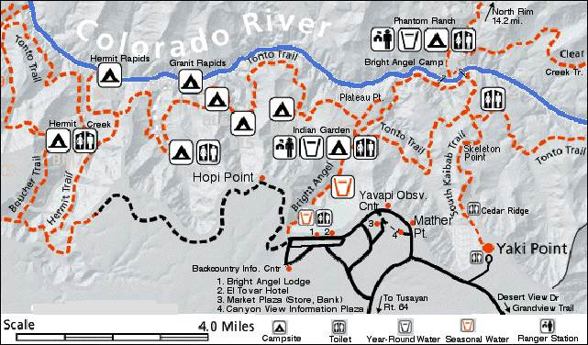

**Fitness Plan Backpacking X-Grand Canyon Here, Jason Ivy, Erin, & wt do a pre-hike at Palo Duro Canyon to get ready for the trek.**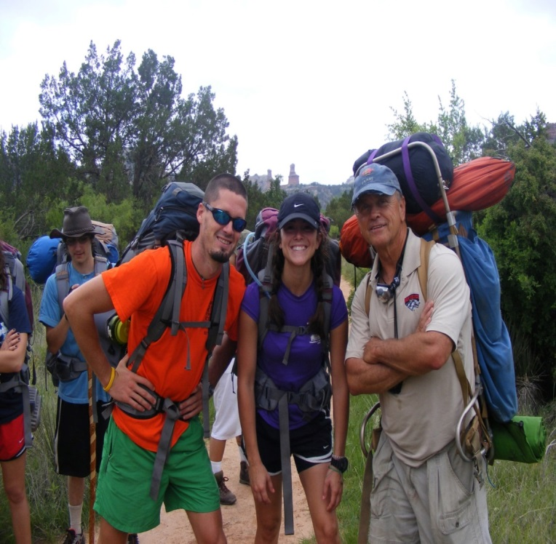

*Stretch! & Cardio! & Strength Training! = Success*

**Cardio:** 5 DAYS A WEEK!!!!! Starting at 30 minutes working up to at least 1 hour – please pick your fun activity from the selection below!

Walk on treadmill elevate to 10 in May and 15 in June: Walk bleachers at a stadium once a month

Walk with a load in a pack (we will provide one with weights to help)

Jog – 30 minutes

Swim &Elliptical machines

*(never have 2 hard days in a row but be active every day)*

**Strength Training:** 2 days a week!!!!!!!!!!!

Back – seated row, lying back extension, shrugs

Shoulders – shoulder press, lateral press, bench press

Legs – extensions, leg press, leg curl, toe raises, lunges

Stomach – crunch machine, leg raises, torso machine

If you do not have time to W/O -don’t sign-up!

**Day 1**: **Camping on the rim at 8,000’** 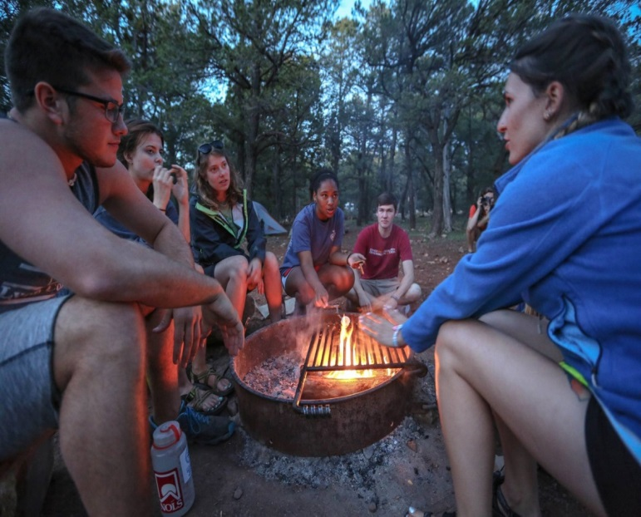

**Day 2** – Begin an early **hike to Cottonwood** – Here’s the view looking at the South Rim from near the top of the North Rim. It’s 8 miles down to Cottonwood Campground (gonna be hot but we can escape to Ribbon Falls or relax under the trees)

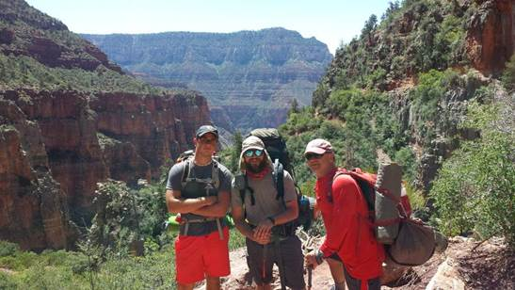

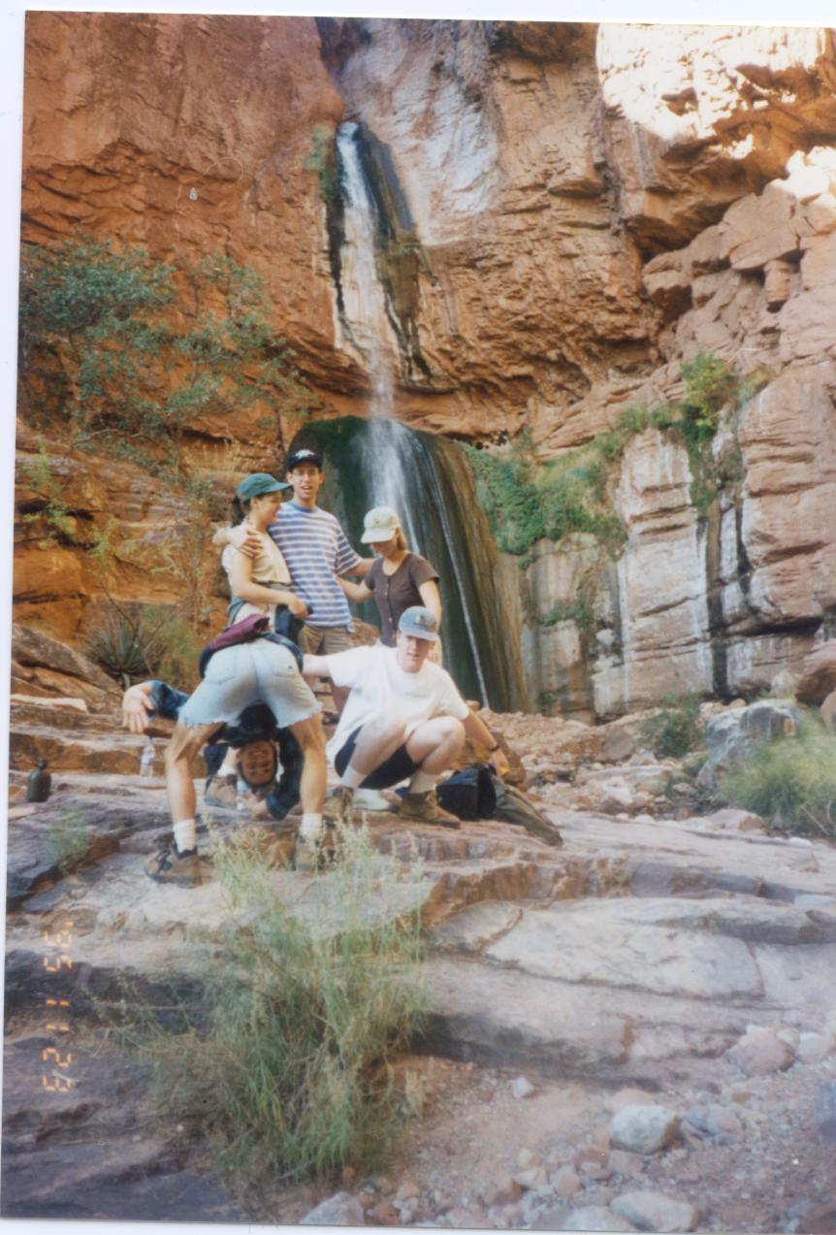

**See you @ Ribbon Falls!** But due to the heat, we will go in the late afternoon of the 4th of July!Here is Andy Martin from TN & Iowa fame relaxing by the falls In the background, the water fall is over 100’ and you can climb behind it

**Day 3** begin hiking down the **6 miles to Bright Angel Campground** on the Colorado River, **Bring $** because the canteen there is open in the afternoon (during the hottest times – 100-110 degrees-be sure to jump in the Cold water of Bright Angel Creek also) to play cards or read and then there is a ranger program at 7pm and the canteen opens again at 8-10pm for socializing/snacks

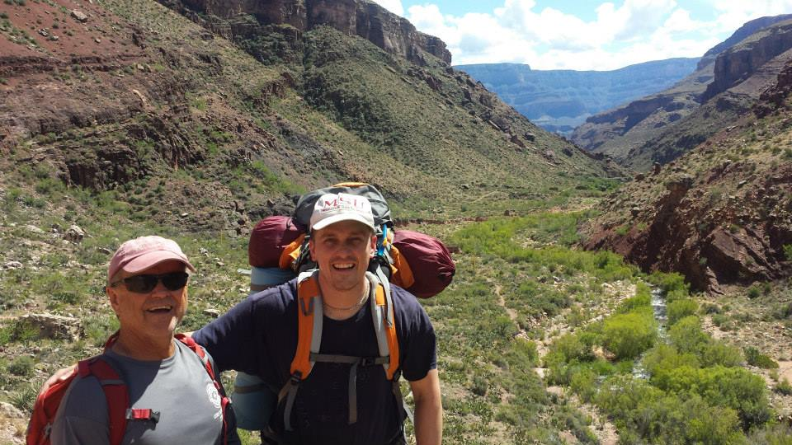

WT & Matt Webb with only 6 miles to go to Bright Angel

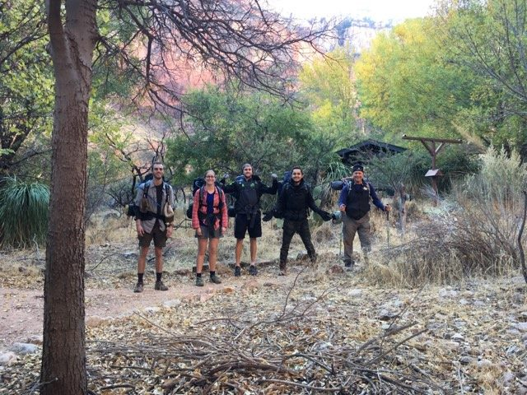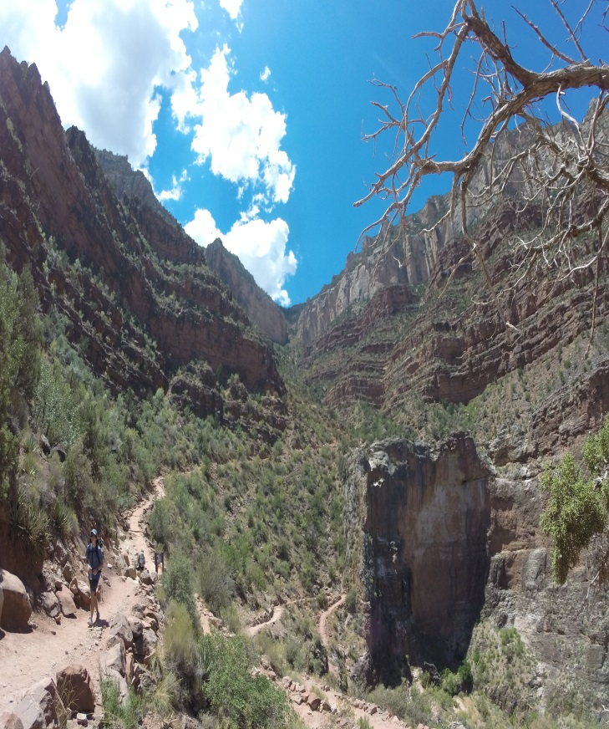

The group gets ready to leave the shade trees of Bright Angel and to start up the trail – I recommend jumping in the Colorado River (45 degrees) to cool off at the 1.5mile mark/of the 4.5 up the trail

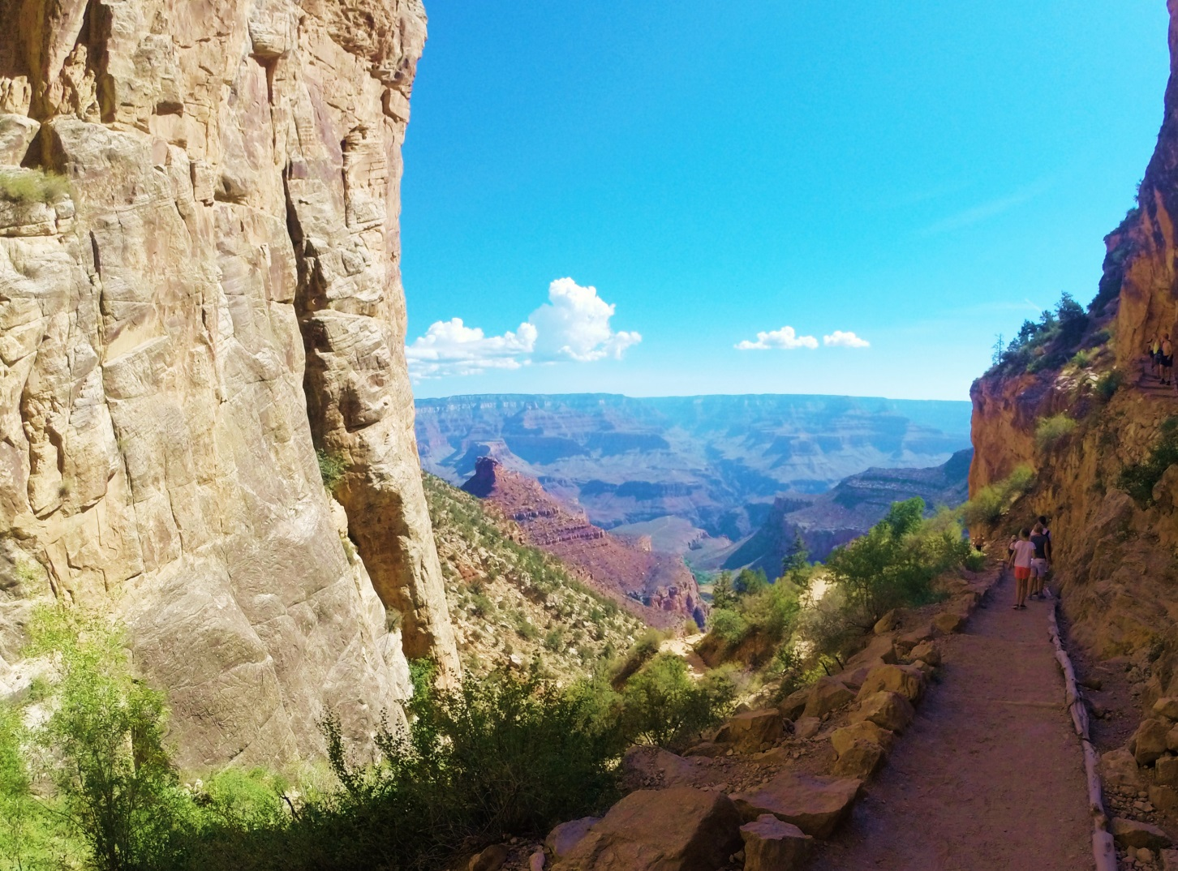

You are almost out!

At the end, have a group photo on the South Rim; Here are Travis, wt, Eddie posing outside the best showers in the world! (be sure to bring 8 quarters)

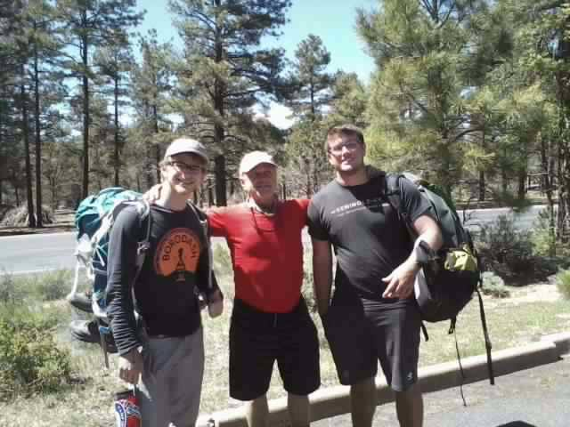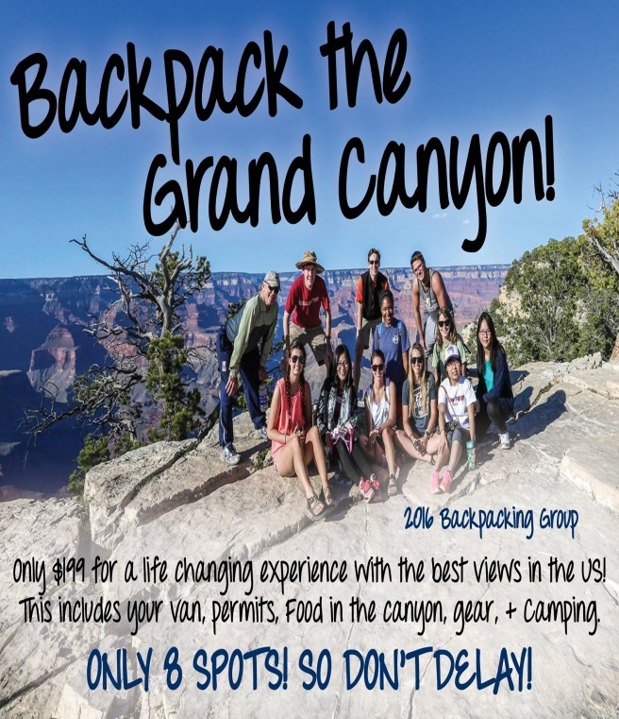

After your shower, try on that new trip shirt you “earned” going up the canyon like this group from 2016

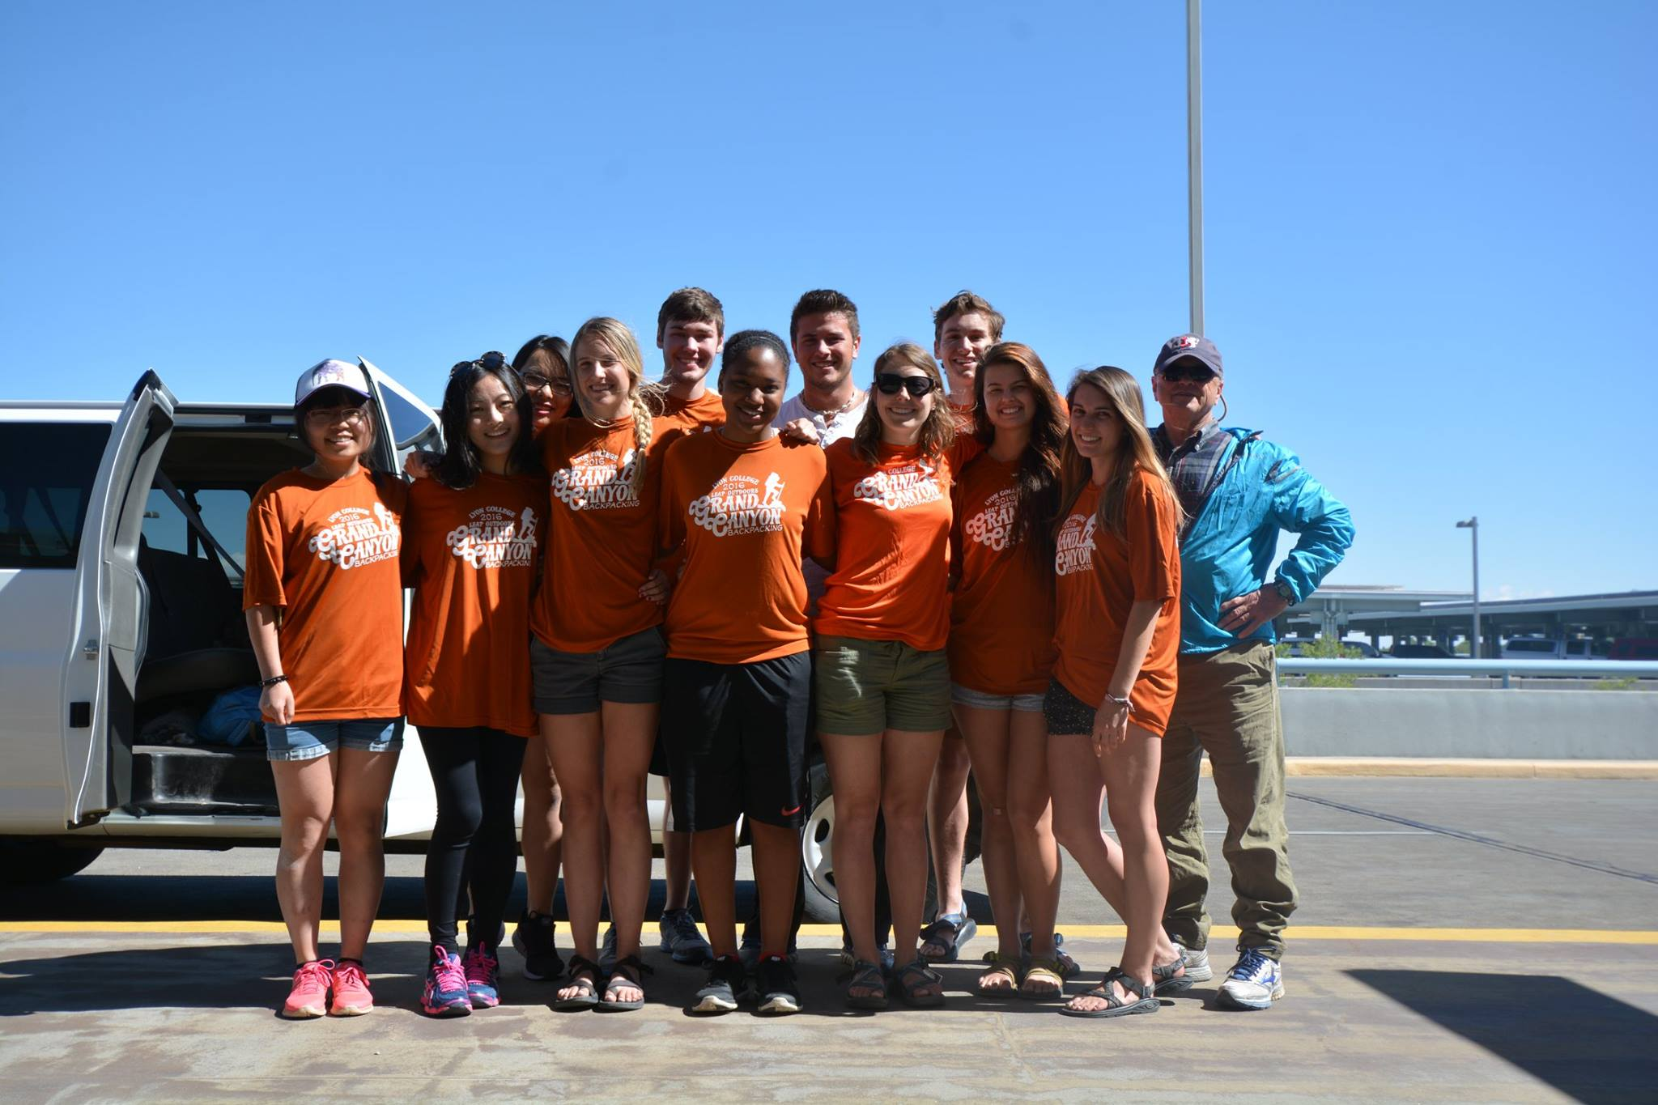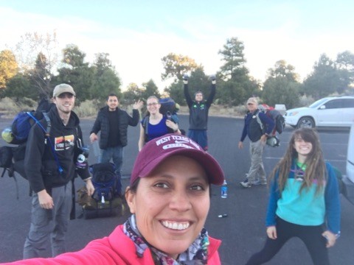

Then Take a SELFIE that you made IT!